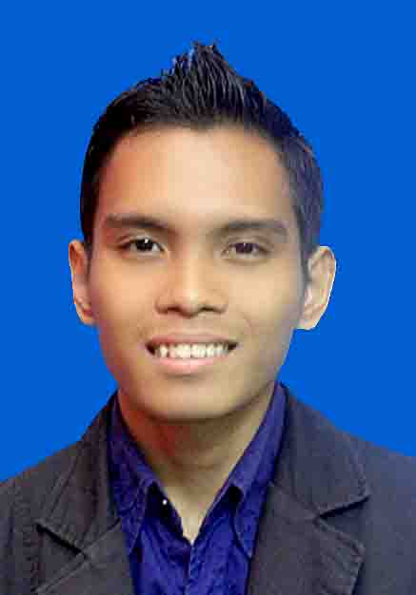

**MOHAMMAD RIZAL BIN KAMARUZAMAN**

🌎 PT 921 LORONG SCT 3, KG. SG. CHIK TAMBAHAN, HULU YAM BARU, 44300 BATANG KALI, SELANGOR

📱 017-3622682

📧 rizal8895@yahoo.com

**◔ Personal Skills**

LEADERSHIP

● ● ● ● ● ● ● ●

CREATIVITY

● ● ● ● ● ● ● ●

COMMUNICATION

● ● ● ● ● ● ● ●

INTERPERSONAL

● ● ● ● ● ● ● ●

**◔ Professional Skills**

MICROSOFT OFFICE

● ● ● ● ● ● ● ●

MANAGEMENT

● ● ● ● ● ● ● ●

TECHNICAL

● ● ● ● ● ● ● ●

**👦 Profile**

My name is Mohammad Rizal Bin Kamaruzaman. I am student from Universiti Tenaga Nasional taking Bachelor of Electrical Power Engineering. Seeking internship challenge where I can utilize my skills.

**🎓 Education**

❶  *Primary School*

*Sekolah Kebangsaan Bandar Baru Batang Kali (2005-2007)*

*UPSR- 4A 1B*

❷ *Secondary School*

*Sekolah Menengah Kebangsaan Syed Mashor (2008-2010)*

*PMR- 8A*

*Sekolah Menengah Sains Tuanku Munawir,Seremban (2011-2012)*

*SPM- 5A 4B*

❸  *University*

*Universiti Tenaga Nasional (Bachelor in Electrical Power Engineering)*

*Current CGPA- 2.38*

**Activities**

❶ *High Committee in Board of Prefects ( Secretary )*

*// 2008-2010*

❷ *Represents school in Australian Mathematics Competition*

*Achievements- Bronze Medal*

❸ *Represents UNITEN in Kejohanan Wajadiri Nasional Silat Cekak Hanafi*

*Achievements- 4th place*

**Languange**

**Interests**

🎧 🎮 🎳 📷 🔧 🗼